A short description of the assignment | The "Unit Converter" application is a tool enabling users to convert units of measurement in various categories such as Distance, Weight, and Volume. It provides an interface for selecting a category, giving input values, choosing conversion type (units), and displaying the converted result. The application utilizes Angular 17 to build a modular and responsive front-end.  User starts on the home page where they can user Unit Converter tool.  User can select a conversion category (e.g., Distance, Weight, Volume), then the corresponding icon is shown.  After selecting a category, users enter the value they want to convert and choose the conversion type (e.g., meters to miles).  Conversion happens automatically without pressing a button (however, it can also be implemented without difficulty) and the result is displayed.  Each of the 3 categories contains 4 conversion types.  There is also an about page that can be accessed via navigation bar icon. Then user can return to home page clicking a "Back" button without reloading browser window.
Grade level your are aiming to | 4
Features implemented | - Used components in the implementation  - Designed the component structure  - Conversion result is displayed automatically (=no convert button)  - Angular data binding is used in implementation  - Implemented three conversion categories and 12 converters (e.g. 4 converters per category).  - Automatic icon display of the selected conversion category is implemented.  - Angular service is used to implement the conversion operation.  - Dependency injection is used to inject service into the components needing the service  - Angular material is used in the UI  - Source code is readable and clean  - Routing implementation e.g. the toolbar icon has a link to about screen and a way to get back to the home screen without browser reload operation (button)
Features not implemented | The converter category and conversion selection box  values are filled programmatically
A short description of components and their responsibilities | AppComponent:  Serves as the root component of the application.  Responsible for the overall layout and structure of the application.  Acts as the main container for other components that are included into HomeComponent or AboutComponent and hosts navigation.  HomeComponent  Represents the homepage or initial view of the application.  Incapsulates inside its HTML file all the components to be showb on the main page besides navigation.  CategorySelectorComponent  Responsible for enabling the user to select a specific category and display a corresponding icon.  Offers dropdowns for choosing a category.  ConverterComponent  Central component for handling conversions  Allows users to input values, choose types of conversion (units to units) via dropdown menu, and trigger the conversion process.  Communicates with services like ConversionService to carry out the conversion.  Emits the results of the conversion for display in ConversionResultComponent.  ConversionResultComponent  Responsible for displaying the results of conversions performed by the ConverterComponent.  Receives and presents conversion results.  Appears or updates its content when a new conversion result is available.  AboutComponent  Provides information about the application, its purpose  Acts as a standalone page within the application accessed through navigation.
Screenshots from the ui in operation | 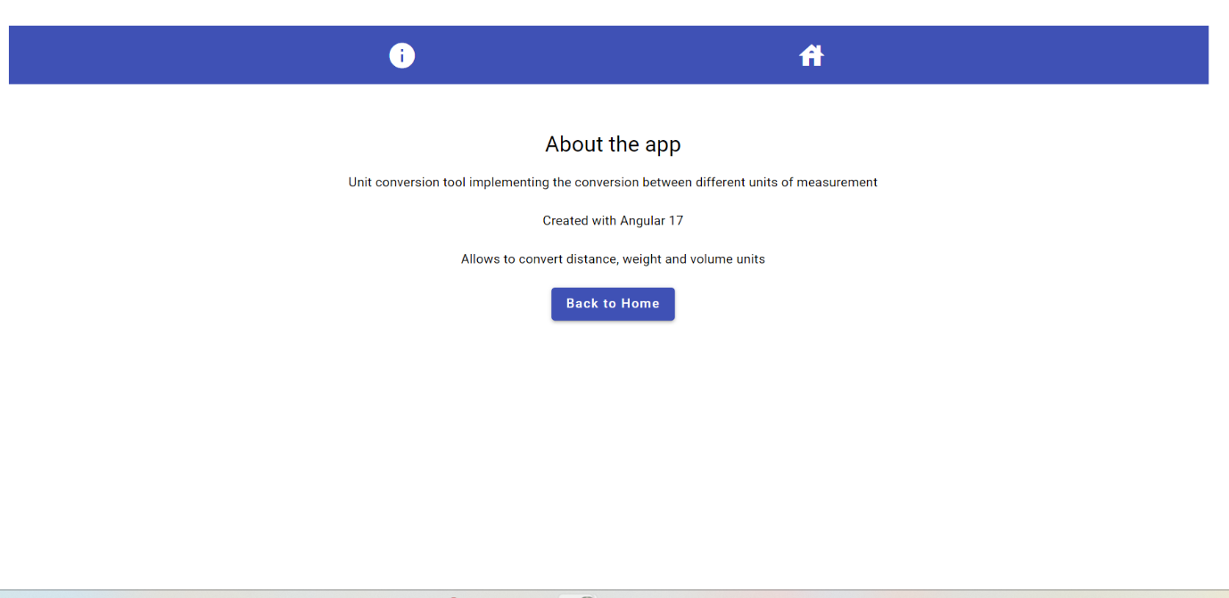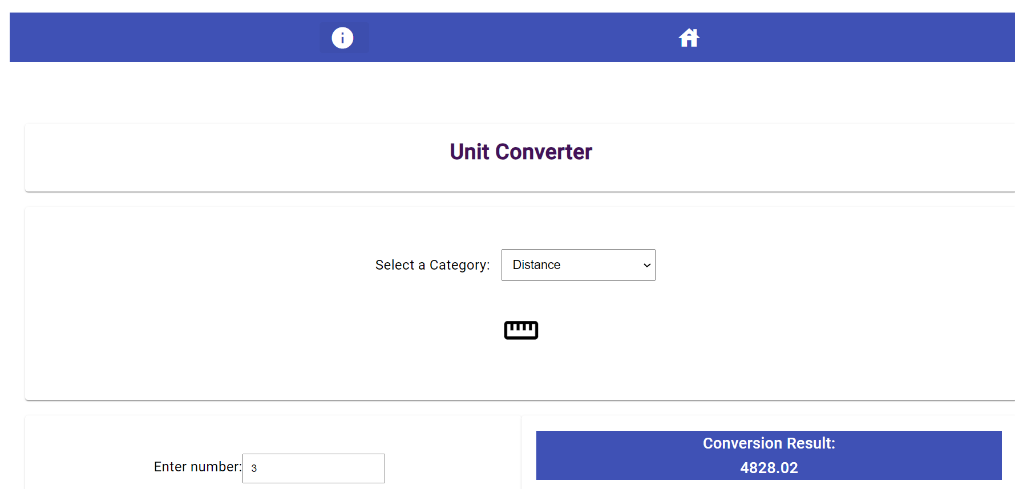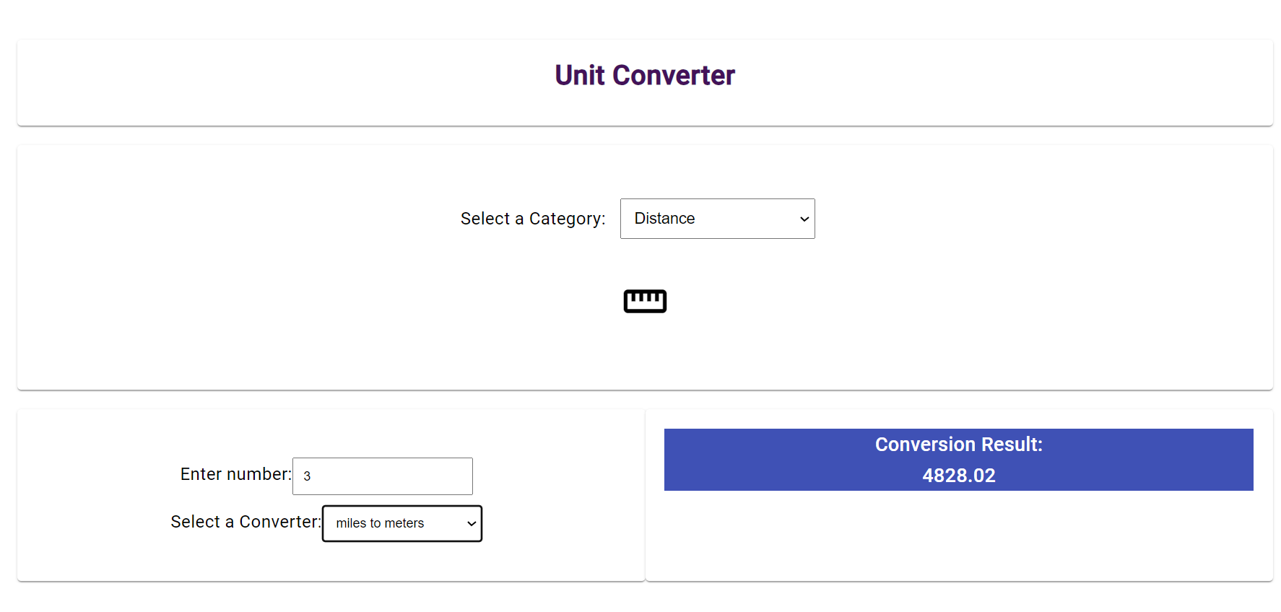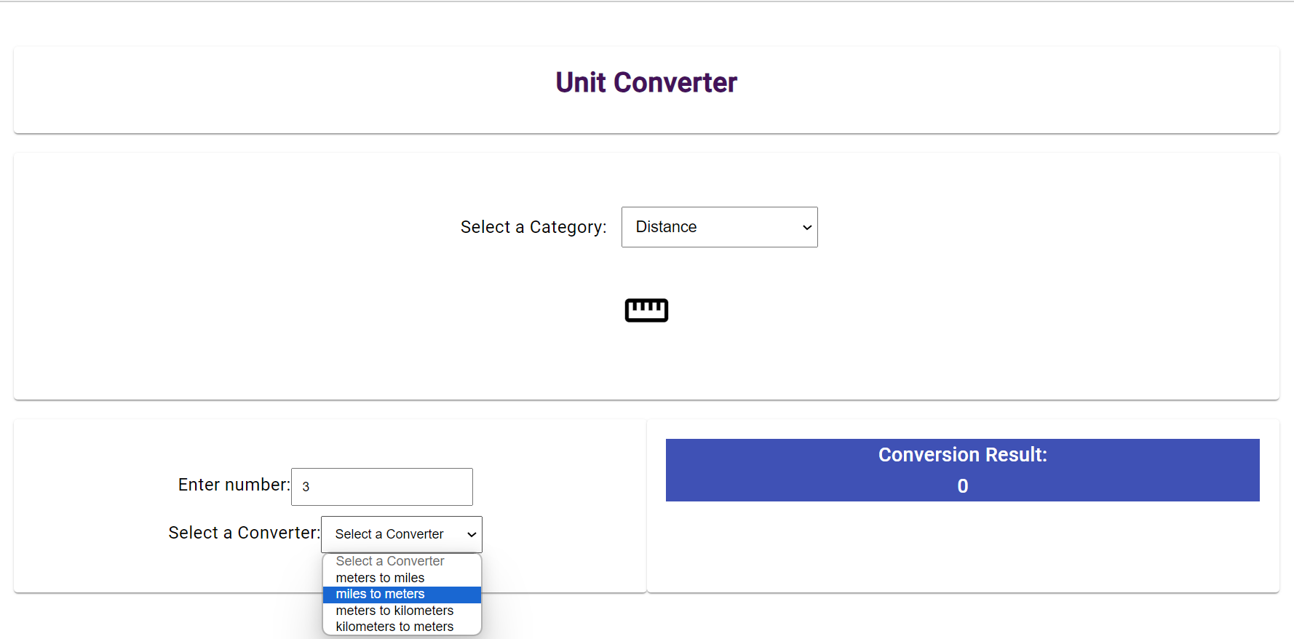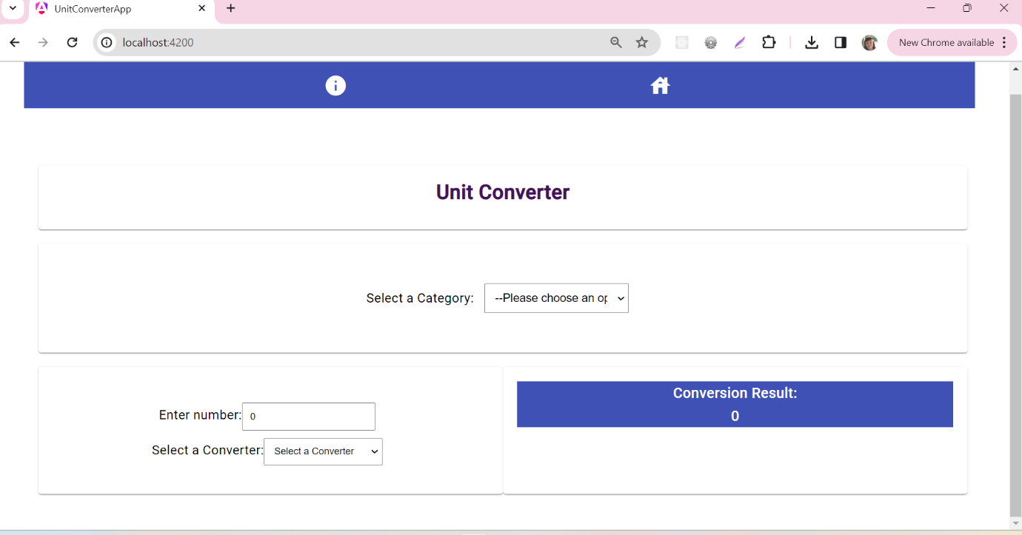  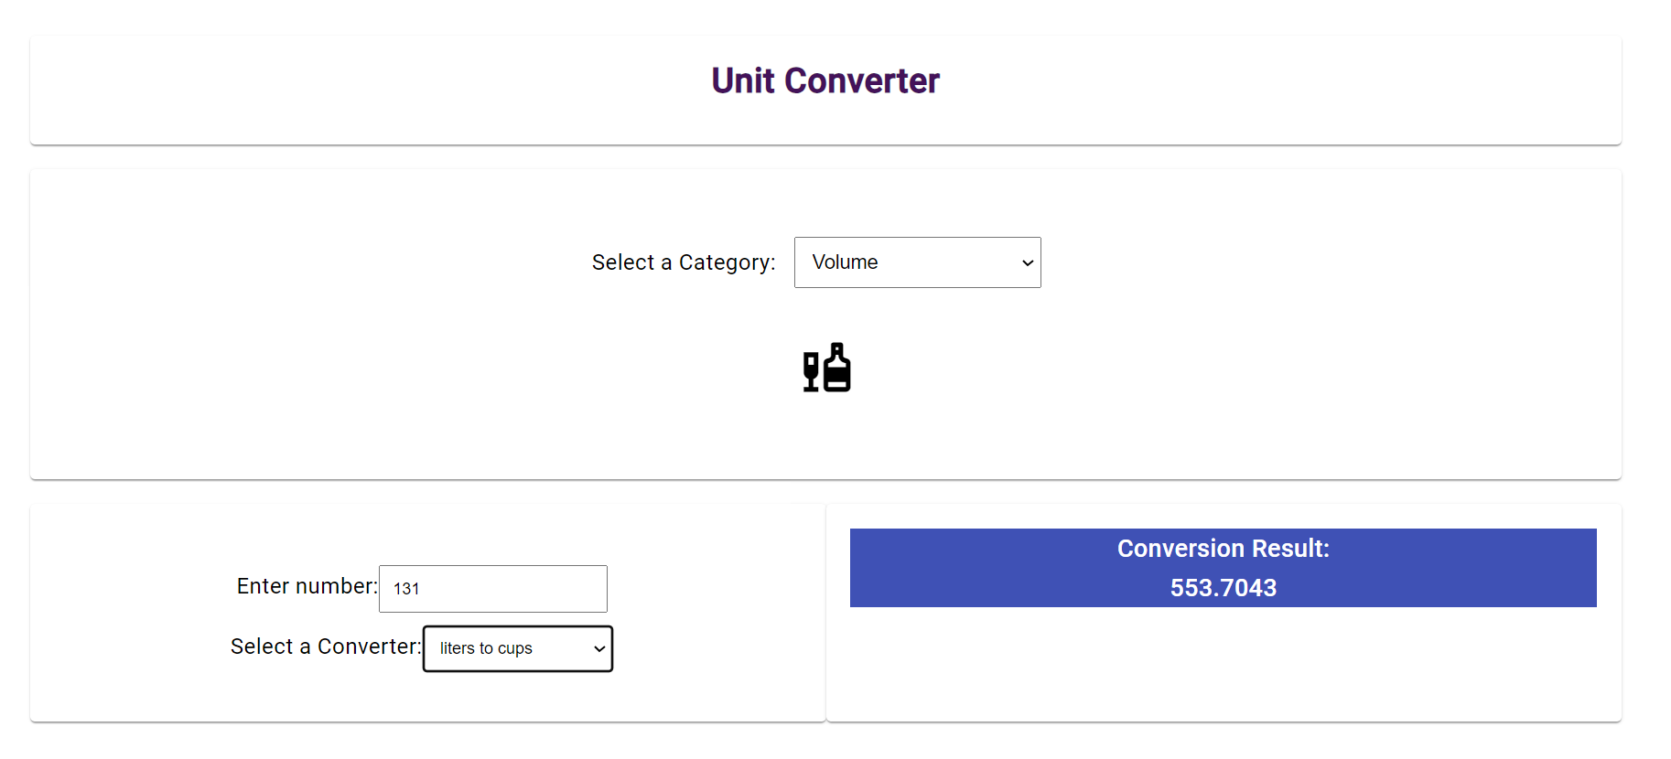
Screenshots from source code | AboutComponent:  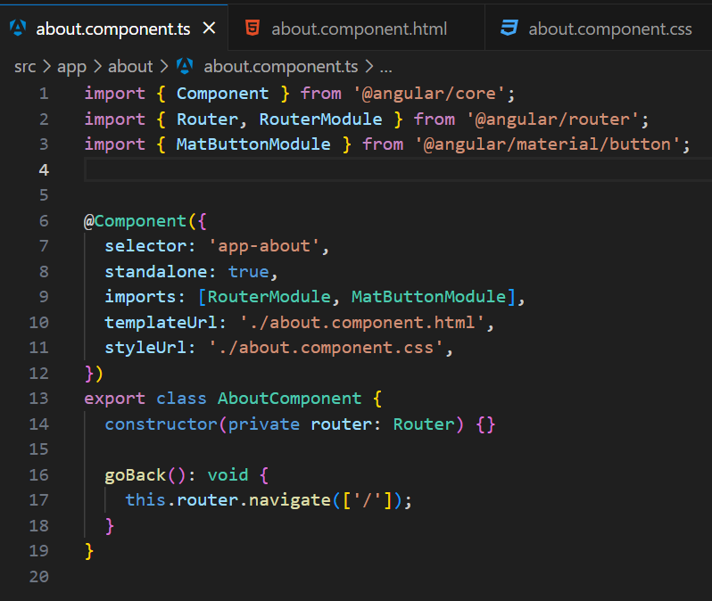  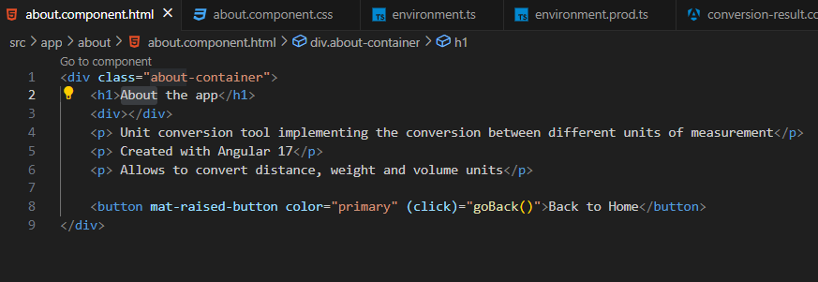  CategorySelectorComponent:  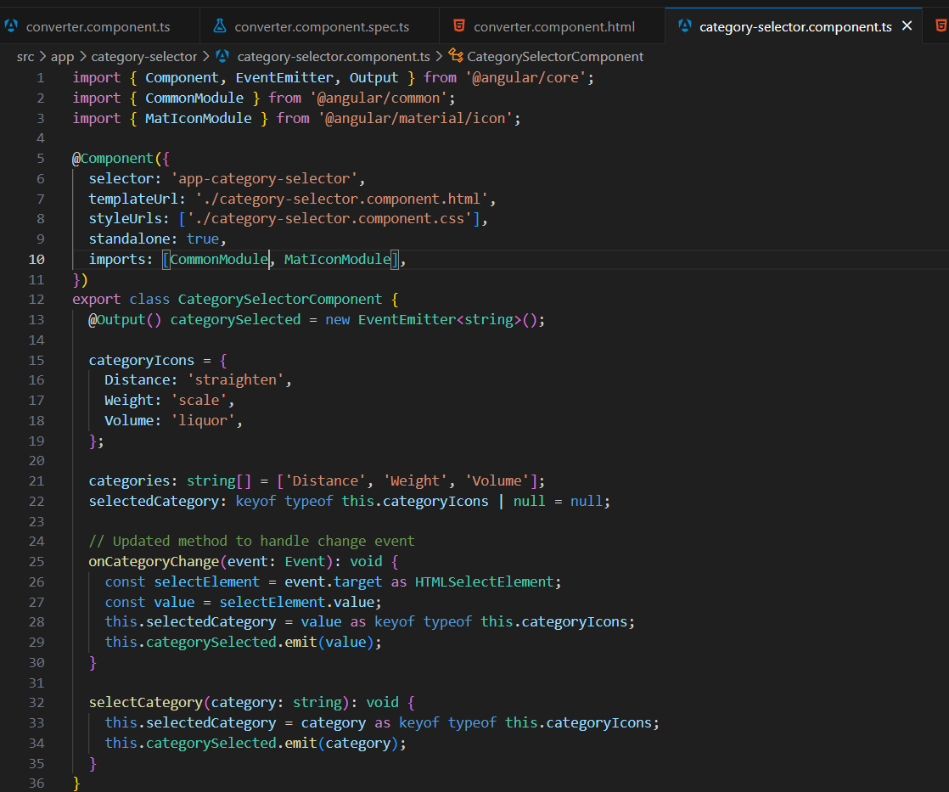  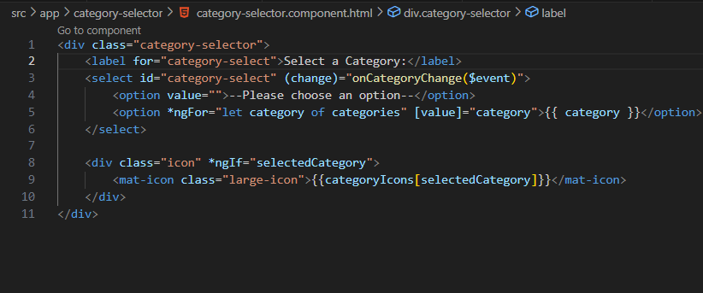  ConversionResultComponent:  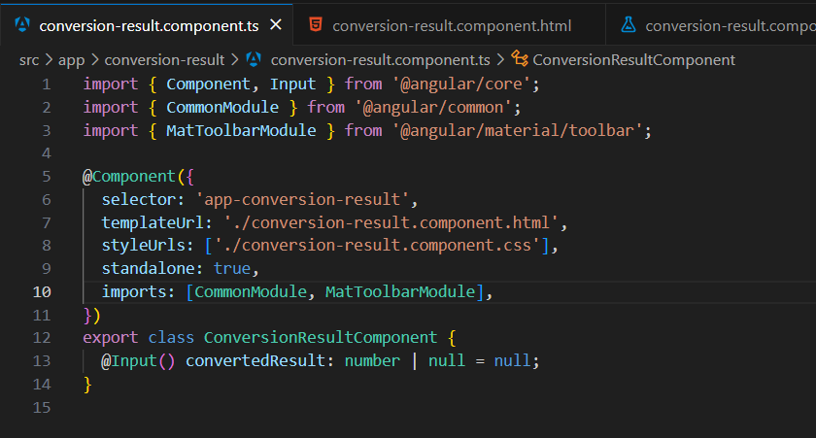  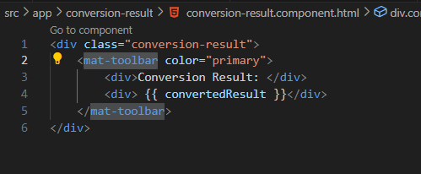  ConverterComponent:  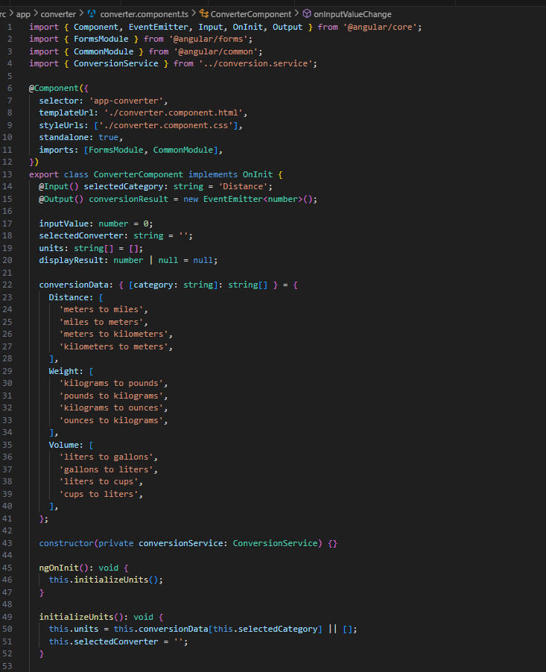  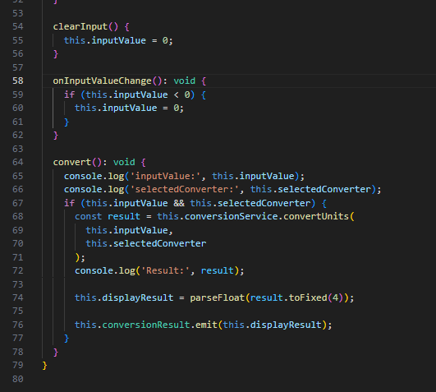  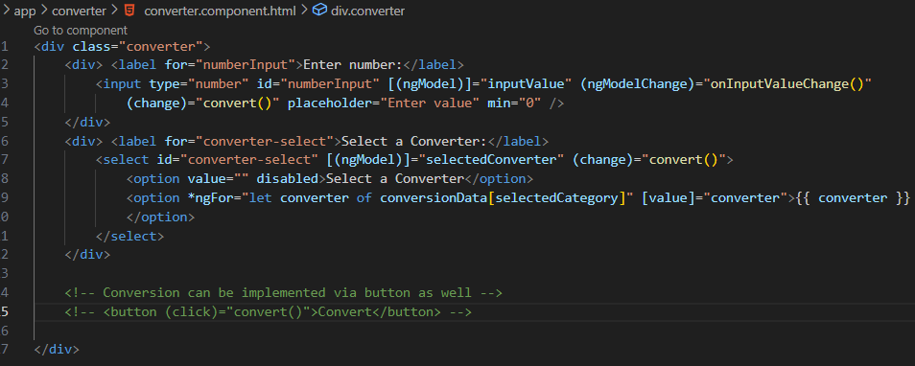  HomeComponent:  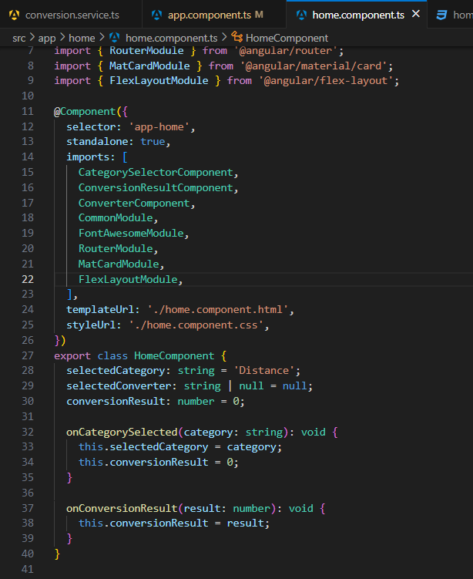  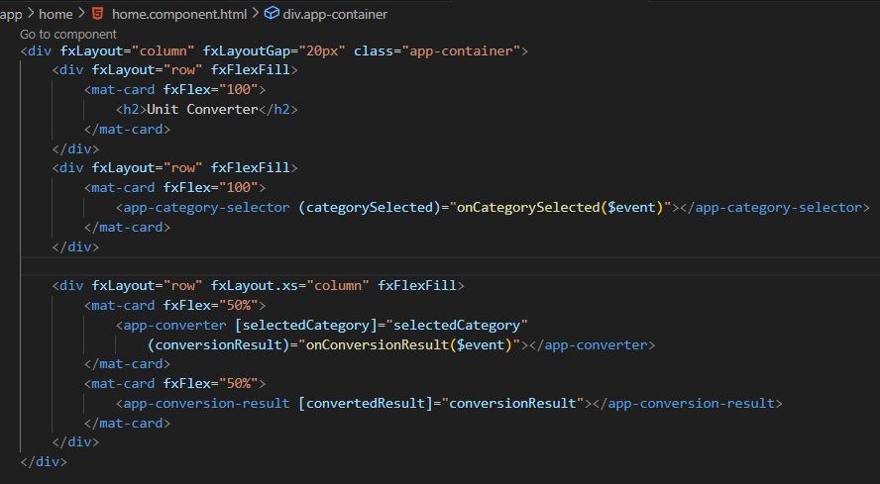  AppComponent:  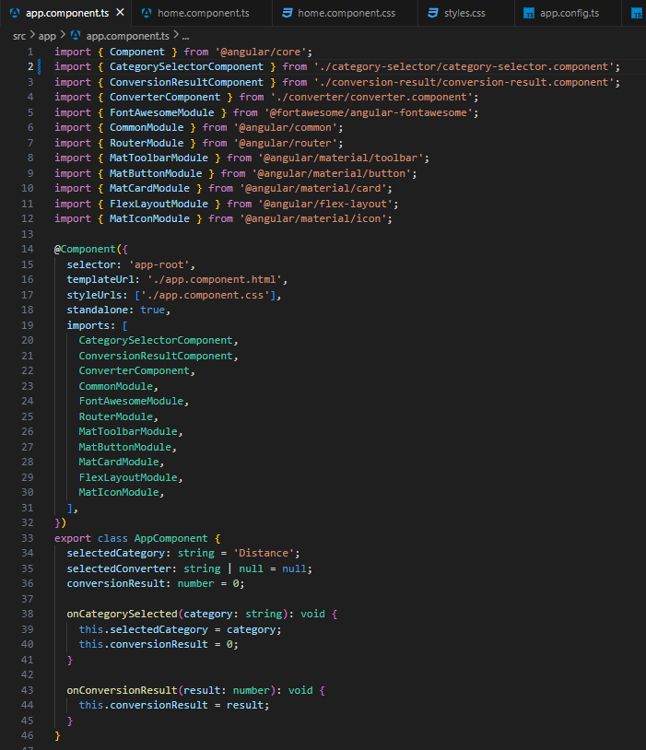  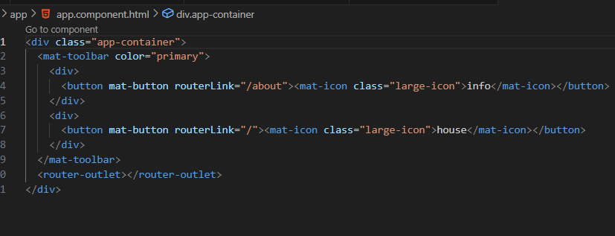  Routes:  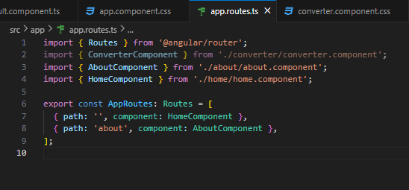  Conversion service:  